ENGINEERING COMPLEXITY INTO CLARITY
SUMIT SHARMA 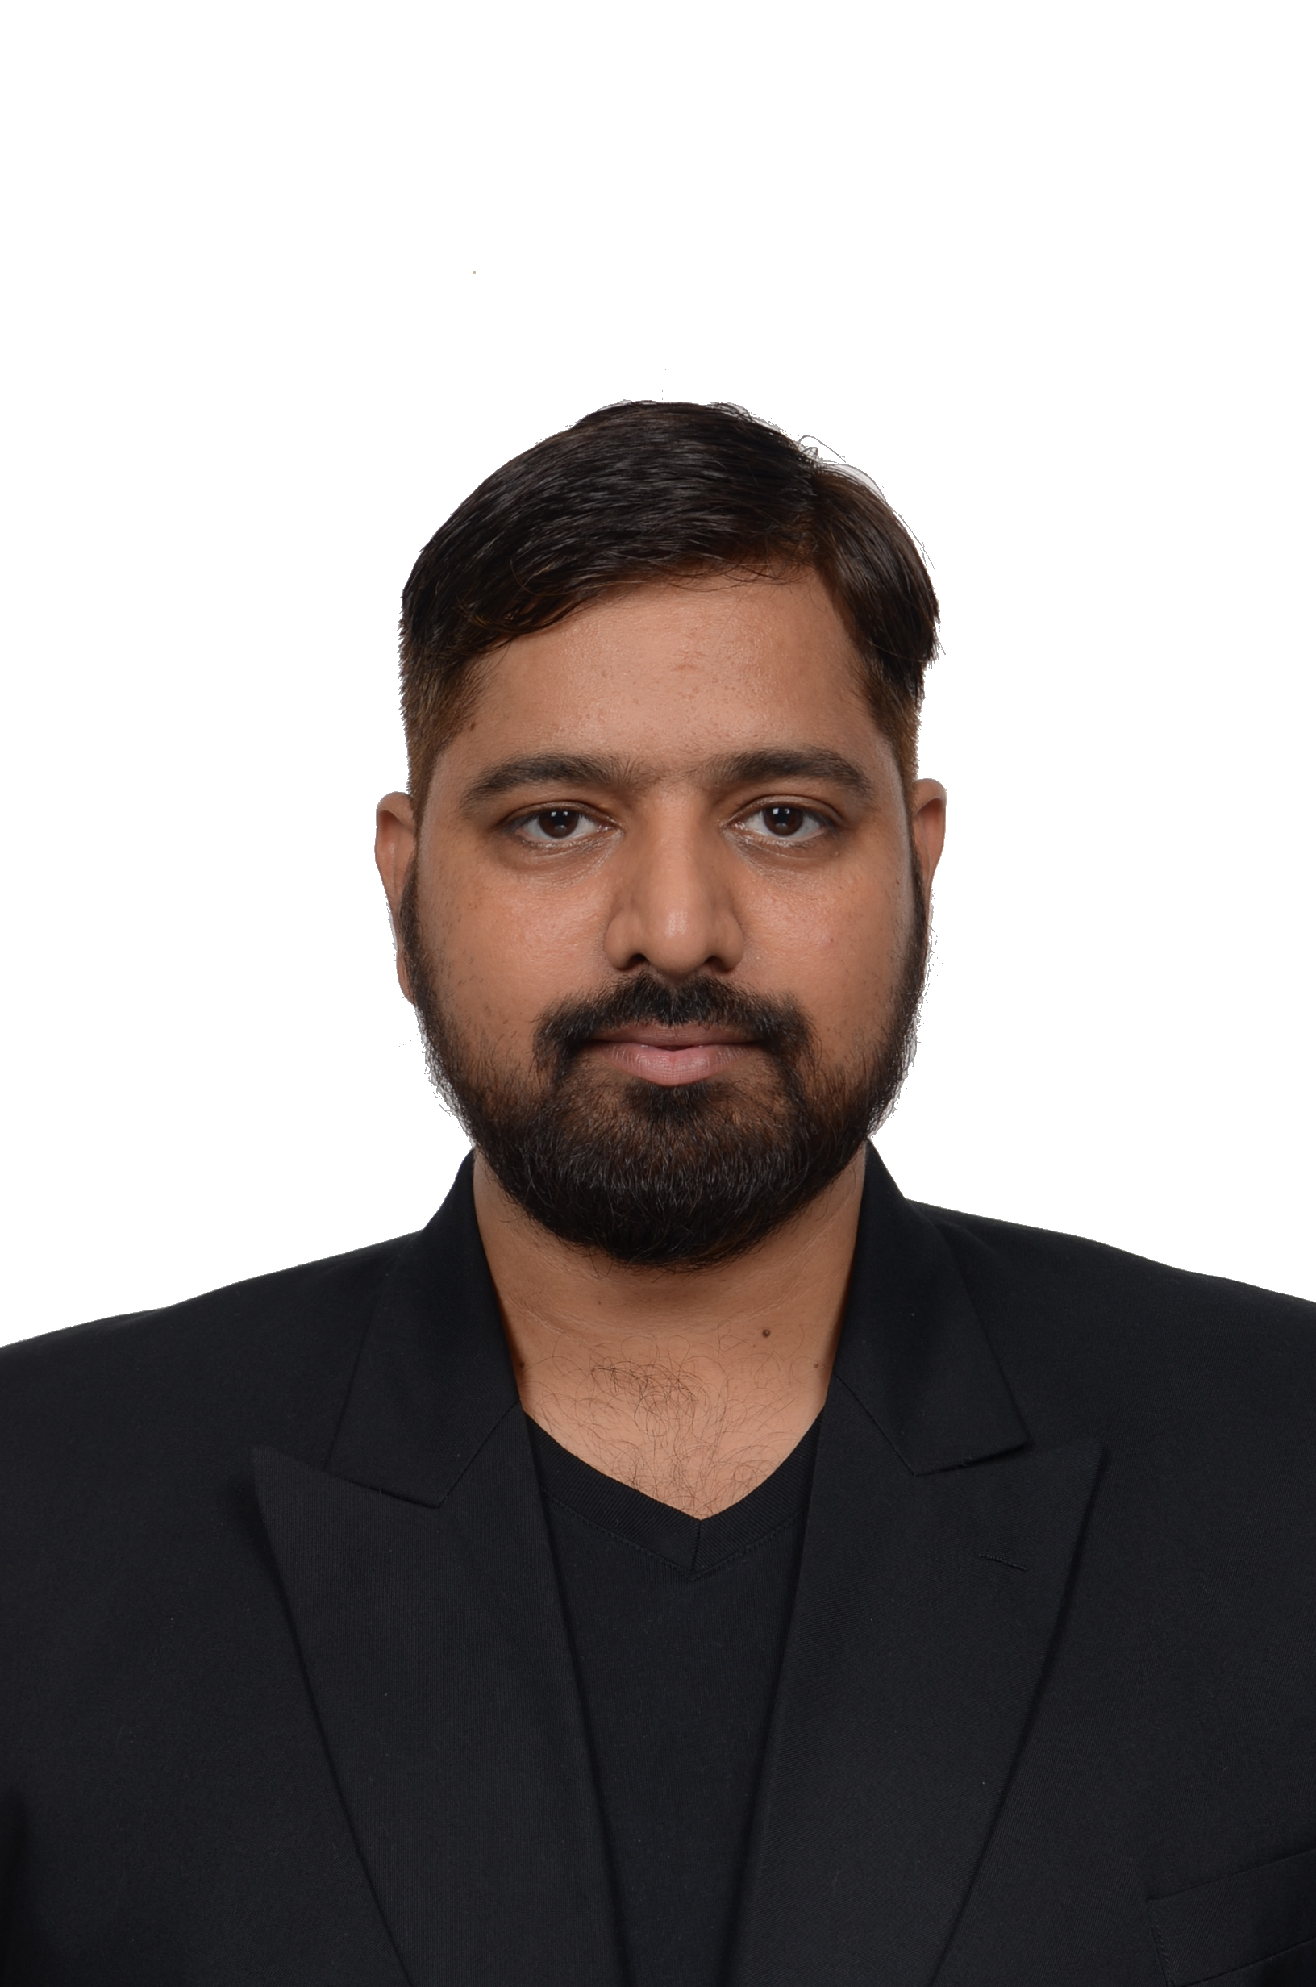
Software Engineer · HPC · Platform Automation
Rotterdam, The Netherlands • +310634646277 • sumitsharma42876@gmail.com
linkedin.com/in/sumitsharmaxinfo • github.com/sumit42876 • sumitsharma.info
PROFILE
Software engineer with 10+ years of experience delivering HPC platforms, infrastructure automation and full-stack products. Currently engineering TrinityX at ClusterVision, with deep hands-on experience across Python, Linux, bare-metal provisioning, cloud, observability and large-scale Intel automation environments. Known for translating complex systems into reliable software, clear roadmaps and maintainable engineering practices.
TECHNICAL CAPABILITIES
Software & testing: Python, Flask, Django, FastAPI, PyQt, Robot Framework, PHP, JavaScript, React, REST, SOAP, SQL, JSON, XML
HPC & platforms: HPC, bare metal, Rocky Linux, Red Hat, Ubuntu, Windows, PXE, FOG, OneCloud, DHCP, DNS, networking, firewall, routing, NAT
Cloud & automation: Azure, AWS, GCP, Ansible, Bash, Terraform, Docker, Kubernetes, CI/CD, Jenkins, PowerShell, Chocolatey, Artifactory
Observability & data: Prometheus, Grafana, Zabbix, MySQL, MariaDB, PostgreSQL, MongoDB, Couchbase, CouchDB, SQLite
Delivery & leadership: Architecture, technical roadmaps, Agile, Scrum, mentoring, team leadership, Jira, Confluence, GitHub, GitLab, Bitbucket
EXPERIENCE
Software Engineer Jun 2022 — Present
ClusterVision B.V. — Rotterdam/Amsterdam, NL
- Engineer TrinityX, ClusterVision’s open-source HPC, AI and cloud platform, across provisioning, automation, infrastructure services and monitoring.
- Develop Python/Flask services, PyQt tooling, Robot Framework tests and Ansible/Terraform automation for bare-metal HPC environments.
- Work across Rocky Linux, PXE, DHCP, DNS, Prometheus, Grafana, Azure and AWS integrations while creating design documentation and roadmaps.
Technical Lead / Senior System Analyst Oct 2017 — Dec 2022
UST — Intel, Malaysia
- Led engineering for Remote Board Farming, BIOS automation and semiconductor QA systems used by 5,000+ Intel developers.
- Built Python, Ansible and Bash automation around OneCloud, PXE, FOG, Zabbix, Docker, PowerShell and globally distributed test infrastructure.
- Managed engineers, triaged production issues, translated customer requirements and delivered new capabilities in Agile/Scrum teams.

EXPERIENCE CONTINUED
Senior Software Engineer / Team Lead Aug 2015 — Sep 2017
Diro Inc
- Developed product and hospitality platforms with PHP, Laravel, Symfony, React, Java, Spring, Couchbase, REST APIs and Linux automation.
- Led delivery, architecture decisions, issue resolution and collaboration across development and operations.
Software Engineer Jul 2013 — Jul 2015
NamaskaarIndia Pvt. Ltd. / Matrix Techno Pvt. Ltd.
- Built booking and e-commerce engines with Python, PHP, CodeIgniter, Symfony, Django, Node.js, MySQL and third-party APIs.
- Designed backend workflows, commission logic, microservices and reusable deployment patterns for thousands of customer implementations.
SELECTED ENGINEERING PROJECTS
TrinityX GitHub: github.com/clustervision/trinityX
Open-source HPC, AI and cloud platform
Python, Flask, PyQt, Robot Framework, Ansible, Terraform, Rocky Linux, bare metal, Prometheus, Grafana, DHCP, DNS, Azure, AWS
Remote Board Farming
Automated software installation and systems management for 5,000+ Intel developers
Python, Ansible, Bash, OneCloud, PXE, FOG, Zabbix
BIOS Automation
Python automation for Windows and Yocto BIOS validation, power cycles, SSH and test frameworks
Python, Robot Framework, PowerShell, Bash, Flask, Bottle
Zircon QA Tool
Semiconductor quality platform supporting thousands of Intel SOC and IP developers
Python, PHP, Symfony, React, AngularJS, Ansible, MySQL, NGINX
MORE PROJECTS
MyDOC Chatbot
Machine-learning chatbot and web crawler integrated with a production web application
Python, Flask, Pandas, NumPy, web scraping, MySQL, React
Booking Engine
Reusable flight and hotel booking platform deployed across 3,000+ customer implementations
Python, PHP, CodeIgniter, Django, Node.js, REST APIs, MySQL
EDUCATION
Master of Engineering (Computer Science) — Anna University, 2013 · CGPA 8.43
Bachelor of Engineering (Computer Science) — Anna University, 2011 · CGPA 8.48
CERTIFICATIONS
- Professional Scrum Master™ I (PSM I) — Scrum.org, 2026
- Learning Terraform — LinkedIn Learning
- Java (J2SE/J2EE), PHP, C and Ubuntu/Linux professional training
LANGUAGES & INTERESTS
English — professional • Hindi — native • Dutch — A1 • German — A1
Guitar, music, continuous learning and building useful systems.

